SELF BALANCING ROBOT

A MAJOR PROJECT 1 REPORT SUBMITTED BY
ASHWANI RAI 0206EC201012
AYUSHI SHUKLA 0206EC201014
MANAS TIWARI 0206EC201025
SHRUBHI YADAV 0206EC201051

UNDER THE GUIDANCE OF MR. SHAILESH KHAPARKER
IN PARTIAL FULFILLMENT FOR THE AWARD OF THE DEGREE OF
BACHELOR OF TECHNOLOGY
In

Electronics & Communication Engineering


DEPARTMENT OF ELECTRONICS & COMMUNICATION ENGINEERING
GYAN GANGA INSTITUTE OF TECHNOLOGY & SCIENCE, JABALPUR (MP) RAJIV GANDHI PROUDYOGIKI VISHWAVIDYALAYA, BHOPAL

BATCH (2020-2024)


GYAN GANGA INSTITUTE OF TECHNOLOGY & SCIENCE, JABALPUR (MP)

Approved by AICTE New Delhi & Govt. of M.P.
(Affiliated to Rajiv Gandhi Proudyogiki Vishwavidyalaya, Bhopal)

BONAFIDE CERTIFICATE
This is to certify that the major project work entitled “SELF BALANCING ROBOT” is done by Ashwani Rai, Ayushi Shukla, Manas Tiwari, Shrubhi Yadav under our guidance and supervision for the degree of Bachelor of technology in Electronics and Communication Engineering of Rajiv Gandhi Proudyogiki Vishwavidyalaya, Bhopal (M.P.) India. To the best of my knowledge and belief the project embodies the work of the candidate themselves and that the work has not been submitted earlier in part or full for the award of any other degree.

Dr. Neeta Nathani Prof. Shailesh khaparkar
Head of the Department (Project Guides)

DATE………… DATE…………

GYAN GANGA INSTITUTE OF TECHNOLOGY & SCIENCE, JABALPUR (MP)

Approved by AICTE New Delhi & Govt. of M.P.
(Affiliated to Rajiv Gandhi Proudyogiki Vishwavidyalaya, Bhopal)

APPROVAL CERTIFICATE

This is to certify that the major project work entitled is done by “Ashwani Rai
,Ayushi Shukla , Manas Tiwari, Shrubhi Yadav ” is approved for the award of degree of Bachelor of Technology in Electronics and Communication Engineering of Rajiv Gandhi Proudyogiki Vishwavidyalaya, Bhopal (M.P.) India.

INTERNAL EXAMINER: EXTERNAL EXAMINER:
DATE…………………. DATE……………………

GYAN GANGA INSTITUTE OF TECHNOLOGY & SCIENCE, JABALPUR (MP)

Approved by AICTE New Delhi & Govt. of M.P.
(Affiliated to Rajiv Gandhi Proudyogiki Vishwavidyalaya, Bhopal)

DECLARATION
We declare that major project work entitled “SELF BALANCING ROBOT” is our own work conducted under the supervision of Prof. Shailesh Khaparkar Electronics& Communication Engineering, at, Gyan Ganga Institute of Technology& Sciences, Jabalpur. We further declare that to the best of our knowledge, the major project 1 does not contain any part of any work which has been submitted for the award of any degree either in this University or in any other University without proper citation.

Ashwani Rai Ayushi Shukla Manas Tiwari Shrubhi Yadav

ACKNOWLEDGEMENT

We are grateful to Prof. Shailesh khaparkar, Gyan Ganga Institute of Technology and Sciences, ECE Department, our Mentors, for their valuable guidance and encouragement throughout the duration of our major project work. We were greatly benefited from the technical discussions we shared with them which helped us in understanding the finer aspects of circuit design.
We thank Dr. Ravindra V Kshirsagar, Principal, Gyan Ganga Institute of Technology and Sciences, Dr. Neeta Nathani, Head of Department, ECE Department, and, our Project Coordinator, Prof. Shailesh khaparkar,, for helping us out continuously during the course of our work. Without their help it would have been difficult to complete this project on time.
Thanks to each and every one who helped us, some way or the other, in successful completion of the project work.

LIST OF FIGURES

Figure Page no.

Figure 1.1 Self Balance Robot 1
Figure 1.2 Layout Idea 2
Figure 1.3 Working Principle 3
Figure 3.2 Sense Tilt & Drive Wheels 10
Figure 3.5 Circuit Diagram 13
Figure 4.1 Arduion IDE 16
Figure 4.2 Soldering KIT 17
Figure 4.3Arduino IDE Software 17
Figure 4.4.a Glue gun 18
Figure 4.4.b Wire stripper 18
Figure 4.4.c Wooden Sticks 18
Figure 4.4.d Computer with internet access 18
Figure 5.2 Structure View of Robot 20
Figure(A) Full View of Robot 20
Figure (B) Front View of Robot 20
Figure (C) Top View of Robot 20
Figure (D) Left View of Robot 20
Figure (E) Right View of Robot 20
Figure 5.3.1 All parts diagram 21
Figure 5.3.2 Robot actual implementation view 22
Figure 5.3.3 Frame 22
TABLE OF CONTENTS
TITLE NAME PAGE NO.
BONAFIDE CERTIFICATE I
APPROVAL CERTIFICATE II
DECLARATION III
ACKNOWLEDGEMENT IV
LIST OF FIGURES V
TABLE OF CONTENT VI
CHAPTER-1
INTRODUCTION 1
  - INTRODUCTION TO SELF BALANCE ROBOT 1
  - SELF BALANCE ROBOT CONFIGURATIONS 2
CHAPTER-2
LITERATURE SURVEY 4
  - SELF BALANCING ROBOT HISTORY 4
  - RECENT DEVELOPMENT 5
CHAPTER-3
DESIGN METHODOLOGY 6
  - SELF BALANCE ROBOT PARTS AND ROLES 8
  - BALANCING TECHNOLOGY 11
3.2.a LANGUAGE & SOFTWARE TOOL USED 12
  - REQUIRED MATERIAL 12
  - GENERAL RULES… 13
  - CIRCUIT DIAGRAM 14
  - HARDWARE COMPONENTS OF ROBOT 15
CHAPTER-4
TOOLS USED 16
  - SOFTWARE AND HARDWARE TOOLS 16
CHAPTER-5
DESIGN AND IMPLEMENTATION 19
  - REQUIRED PATRS 19
  - STRUCTURE OF ROBOT 20
  - IMPLEMENTATION 21
    - FREAME 22
  - BALANCING TEST & TUNING 23
  - UPLOADING THE FINAL CODE &POWERING 23
  - APPLICATIONS 24
CHAPTER-6
RESULT 25
CHAPTER-7
FUTUTRE SCOPE 26
  - FUTURE APPICATION OF SELF BALANCE ROBOT 26
CHAPTER-8
COST ANALYSIS 27
CHAPTER-9
REFERENCES 28
CHAPTER-10
APPENDICES 29
  - CODE 29

Chapter 1

INTRODUCTION

Introduction to self-balance robot
A self-balancing robot, often powered by an Arduino microcontroller, is a remarkable creation designed to maintain its equilibrium while standing upright, emulating human balance. It achieves this feat by continuously monitoring its orientation using sensors like accelerometers and gyroscopes, which provide data about its tilt. The Arduino processes this information and calculates the necessary adjustments to keep the robot balanced. By controlling the speed and direction of its wheels or motors, the robot can correct any leaning or tilting, making it appear remarkably stable. Self-balancing robots serve as both educational tools and practical platforms for understanding control systems, making them a popular choice among robotics enthusiasts and learners.
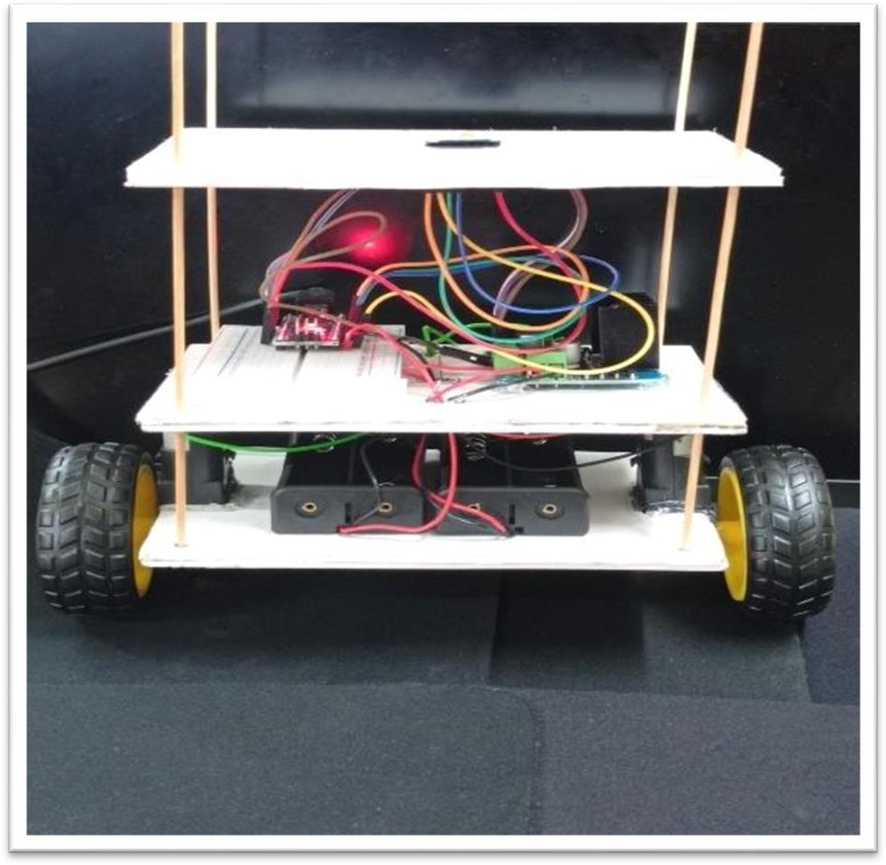

Figure 1.1 SELF BALANCE ROBOIT

Self-balance robot Configurations
A self-balancing robot using Arduino typically involves key components: two motorized wheels, an Arduino microcontroller, and a sensor suite such as accelerometers and gyroscopes. These sensors constantly measure the robot's tilt. The Arduino processes this data and adjusts themotor speeds to maintain balance. It employs a control algorithm like a PID (Proportional- Integral- Derivative) controller for precise adjustments. Additional features like an external chassis and a power supply complete the configuration. Building such robots offers hands-on experience in robotics, control systems, and programming, making it a popular project.
among makers and robotics enthusiasts.

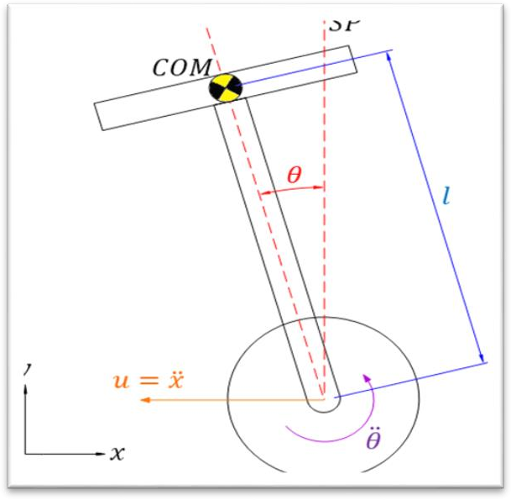
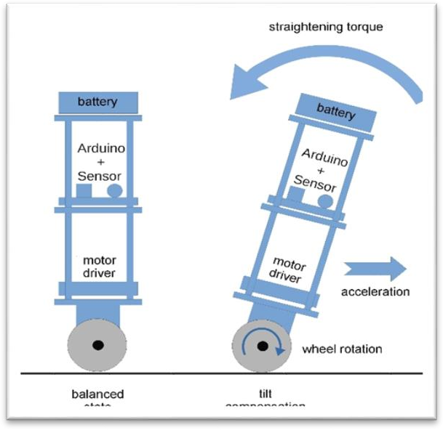

Figure 1.2 l a y o u t i d e a

Moreover, self-balancing robots can be enhanced with wireless communication modules, such as Bluetooth or Wi-Fi, for remote control or data logging. They provide an engaging way to explore advanced concepts in robotics and offer potential applications in areas like personal transportation, security, and automation, making them a versatile and educational project.


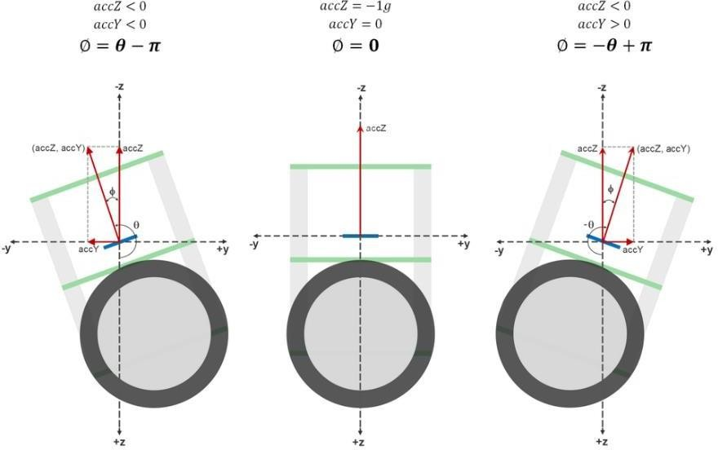

Figure 1.3. Working Principle

CHAPTER 2

LITERATURE SURVEY

Self-balancing robot history
Self-balancing robots, often built using Arduino, have a fascinating history marked by technological evolution and growing accessibility. Early self-balancing concepts emerged in the late 20th century but remained large and costly, mainly for industrial orresearch applications. The advent of the Segway in the early 2000s brought self- balancing technology to the mainstream. Concurrently, Arduino's introduction democratized electronics and robotics for hobbyists. This marked the beginning of DIY self-balancing robot projects, fueled by open-source code and tutorials. These robots use sensors, typically Inertial Measurement Units (IMUs), to detect changes in orientation and position. The core control algorithm, PID, adjusts motor speeds to maintain balance. As technology advanced, self- balancing robots integrated superior sensors, more powerful microcontrollers, and wireless communication. Today, they continue to serve as valuable tools for education, research, and personal projects, and their development remains an active and dynamic field.

FACTS –
    - Sensor Integration: Self-balancing robots use sensors like accelerometers and gyroscopes to measure the robot's tilt and balance in real-time.
    - Control Algorithms: These robots employ control algorithms, such as PID, to adjustmotor speeds and keep balance by responding to sensor data.
    - Versatile Applications: Self-balancing technology is used in various fields, from transportation (like Segways) to educational robotics and automation.
    - Learning Tool: Building and programming self-balancing robots is a fashionable wayto learn about robotics, control systems, and sensor integration in STEM education.
    - Humanoid and Non-Humanoid Varieties: Self-balancing robots come in various forms, from humanoids mimicking human balance to simpler, non-humanoid designs for specialized tasks.
    - Real-World Utility: Beyond educational and entertainment purposes, self-balancingrobots are used in industry for tasks like material transport warehouses and as research platforms in robotics labs.

Recent Development
      - Improved Sensor Technologies: Many advancements have been made in sensor technologies for self-balancing robots. Gyroscopes, accelerometers, and IMUs (Inertial Measurement Units) have become more correct and affordable. These sensors are crucial for deciding the robot's orientationand making real-time adjustments.

      - Advanced Control Algorithms: Self-balancing robots heavily rely on control algorithms to keep stability. Advanced control algorithms, such as PID (Proportional-Integral-Derivative) controllers and Kalman filters, have been used to enhance the performance of self-balancing robots. Researchers and hobbyists continue to refine these algorithms for better stability and smoother movements.

      - Wireless Connectivity: Arduino Nano-based self-balancing robots can now be equipped with wireless communication capabilities, allowing for remote control, data logging, and even autonomous navigation. Bluetooth, Wi-Fi, or other wireless modules enable communication between the robot and a smartphone or a computer.
      - Customization and Add-Ons: The Arduino platform is highly adaptable, and developers have created various add-ons and modules that can be integrated into self-balancing robots. This includes custom-built chassis and frames, battery management systems, and specialized wheels for improved performance.

      - Machine Learning Integration: Some developers have integrated machine learning and neural networks into self-balancing robots to enhance their capabilities. These robots can learn and adapt to different environments and tasks.
      - Open-Source Projects and Communities: Arduino Nano is widely used for self-balancing robots, and the open-source nature of Arduino has led to the development of many self- balancing robot projects and communities. This allows enthusiasts to share their knowledge, collaborate on projects, and access a wealth of resources.

      - Educational Initiatives: Self-balancing robots using Arduino have gained popularity in educational settings. They are used as a hands-on tool to teach students about robotics, control systems, and programming. This has led to the creation of educational kits and tutorials aimed at introducing robotics to a wider audience.
      - Battery and Power Management: Developments in battery technology and power management systems have made it possible for self-balancing robots to run for longer durations on a single charge. Lithium-ion batteries and efficient power management circuits are commonly used to extend operating times.

CHAPTER 3

DESIGN METHODOLOGY

Project Planning:
      - Define the project's aims, scope, and desired features.
      - Create a detailed project plan with a timeline, milestones, and budget estimation.

Part Selection:
      - Choose proper components, including motors, wheels, sensors, microcontroller, and powersource, based on your project requirements.
      - Consider factors like motor torque, sensor accuracy, and battery ability.

Chassis Design:
      - Design or select a chassis that accommodates the chosen components and supplies stability.
      - Ensure the chassis is lightweight yet robust.

Sensor Integration:
      - Integrate the IMU (accelerometers and gyroscopes) to measure the robot's orientation and acceleration.
      - Mount the sensors securely on the chassis to ensure correct data collection.

Motor Control:

      - Implement motor control mechanisms, such as dual H-bridge motor drivers, to control the speedand direction of the motors.
      - Develop or implement motor control algorithms to adjust motor speeds for balance.

Microcontroller Programming:
      - Program the microcontroller (e.g., Arduino) to process sensor data and execute the motor controlalgorithms.
      - Set up communication between the microcontroller and sensors.

Balance Control Algorithms:

      - Implement balance control algorithms, such as PID (Proportional-Integral-Derivative) controllers,to keep the robot's equilibrium.
      - Tune the control parameters to perfect stability.

Power Supply:
      - Select a proper power source, such as rechargeable batteries.
      - Implement voltage regulation and checking to ensure stable power delivery.

Assembly and Wiring:

      - Assemble all components onto the chassis according to the design plan.
      - Carefully wire and connect the sensors, motors, microcontroller, and power supply

Safety Measures:
      - Implement safety features, such as emergency stop buttons or fall protection, to prevent damageto the robot and surroundings.

Documentation:
      - Document the project's progress, including design decisions, code, wiring diagrams, and calibration settings.
      - Create user manuals or guides for future reference.

Presentation and Sharing:
      - Share your project findings and outcomes with the academic and engineering communitythrough presentations or documentation.

Fine-Tuning and Optimization:
      - Continuously perfect the robot's performance, fine-tune algorithms, and address any issues thatarise during testing.

Self-Balance Robot Parts and Roles

COMPONENT NAME | IMAGE | ROLE
ARDUINO NANO | 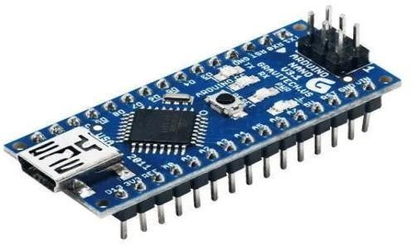 | The Arduino Nano functions as the central controller, processing sensor data, controlling motors, and ensuring balance in a self-balancing robot.
MPU-6050 | 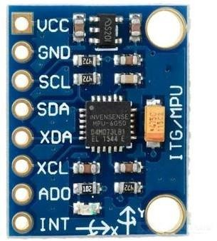 | The MPU-6500 is a crucial sensor, measuring acceleration and gyroscopic data to calculate the robot's orientation, enabling precise self- balancing control
L298N Motor Driver | 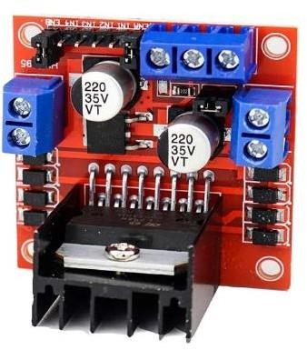 | The L298N motor driver controls the robot's motors, adjusting speed and direction based on input from the controller Arduino for self-balancing and movement

BO Motor | 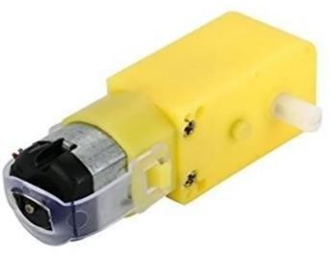 | BO (Brushed DC) motors provide the robot's propulsion and balance control. The Arduino adjusts their speed and direction for self- balancing and movement
BO Wheel | 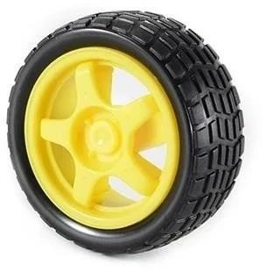 | BO (Brushed DC) wheels are responsible for the robot's mobility. They rotate to move the robot forward, backward, or turn, affecting its self- balancing capabilities.
Sun Board |  | A sun board sheet is typically used for the body or chassis of the robot. It provides a lightweight and sturdy structure to house and protect the robot's components and mechanisms while keeping the overall weight low for improved self- balancing  performance.

Battery Holder | 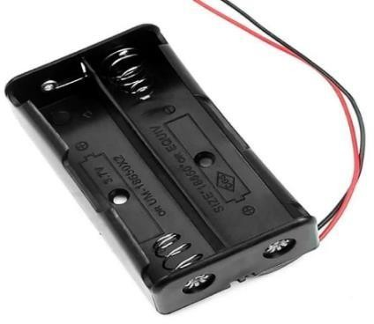 | A battery holder secures and provides a connection for the robot's power source (batteries). It ensures stable power supply for the motors and control systems in a self-balancing robot.
Jumpers |  | Jumper wires facilitate electrical connections between components on a robot's circuit board, allowing the flow of signals and power, which is essential for communication and control in a self- balancing robot
Breadboard | 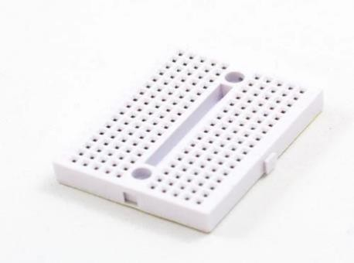 | A breadboard serves as a prototyping platform for connecting and testing electronic components and circuits, including sensors and controllers, in a self- balancing robot. It allows for easy experimentation and design without soldering

Balancing Technology
Balancing a three-level self-balancing robot is a sophisticated process that relies on sensor feedback, precise control algorithms, and efficient motor control. Key components include accelerometers and gyroscopes like the MPU-6050, which measure the robot's tilt angle and angular velocity in real-time. An essential aspect is the control algorithm, often a Proportional-Integral-Derivative (PID) controller, which processes sensor data and calculates the error—a deviation from the desired upright position. The motors, typically two, adjust their speed and direction based on the PID controller's output, enabling the robot to counteract tilting by increasing or decreasing power to each motor. The center of mass's proper location is critical, ensuring it aligns over the wheels to facilitate balancing. Calibration, fine-tuning of PID parameters, and extensive testing are necessary for optimal performance and stability. Safety measures like emergency stop mechanisms are crucial to halt robots in case of instability. Ultimately, maintaining balance in a three- level self-balancing robot involves a continuous feedback loop that iteratively corrects its position, enabling it to navigate and remain upright in various conditions.


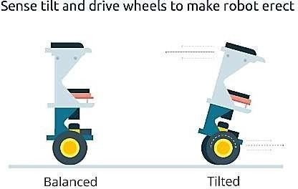

3.2.a Language and software tool used.

    - Front end: C /C++ language
    - Operating system: windows 11
    - Software used: Arduino IDE

Required Hardware

- Chassis: The chassis is the main body or framework of the robot. It supplies structural support for allother components and houses the essential electronics. It should be sturdy yet lightweight to ensure stability and mobility.

- Wheels: Self-balancing robots typically have two wheels mounted on either side of the chassis. These wheels are usually driven by motors and handle the robot's movement.

- Motors: Each wheel is attached to a motor, which supplies the necessary propulsion. These motors can be either DC 60 RPM motors or stepper motors, depending on the design and control system.
- Sensors: Sensors play a crucial role in balance control. Typically, you'll find Inertial Measurement Units (IMUs) that include accelerometers and gyroscopes. These sensors measure the robot's orientation and acceleration, supplying data for balance adjustments.

- Microcontroller (e.g., Arduino): The brain of the robot is a microcontroller, such as an Arduino or similar device. It processes sensor data and calculates the required motor adjustments to keep balance.

- Battery: A power source, typically a rechargeable battery, supplies energy to the motors and electronic components. It should be chosen to balance weight, ability, and operating time.

- Motor Driver: Motor drivers are electronic components that control the speed and direction of the motors based on the commands from the microcontroller. They ensure precise motor control.

- Control Algorithms: Self-balancing robots rely on complex control algorithms, such as PID (Proportional-Integral-Derivative) controllers. These algorithms continuously adjust the motor speed to keep balance.

- Enclosures: Depending on the design and purpose, your robot may have added enclosures or covers to protect sensitive components and supply a polished appearance...

GENERAL RULES: -
- Weight Distribution: Carefully distribute the weight of components on the robot to ensure it still isbalanced and avoids tipping over during operation.
- Largest Payload: Decide and specify the largest allowable payload capacity of the robot and avoidexceeding this limit to keep stability.

- Battery Capacity: Select batteries with a proper capacity to supply sufficient power for the robot'soperation, and ensure they meet the runtime requirements.
- Voltage Regulation: Use voltage regulators or power management systems to keep consistent voltage levels, preventing potential damage to sensitive components.

- Power Budget: Calculate the power budget to ensure that the batteries have enough capacity to runthe robot throughout the desired duration without interruptions.
- Weight Limits: Set weight limits for individual components or add-ons to prevent overloading therobot and affecting its self-balancing capability.

- Environmental Conditions: Consider the impact of external factors, such as terrain, temperature,and humidity, on the robot's performance and adapt its design accordingly.

- Motor Overheating: Implement measures to prevent the motors from overheating, such as using motors with the proper power rating and supplying cooling solutions.

- Part Quality: Choose high-quality components to reduce the risk of failure or malfunctions duringoperation.

- Redundancy and Backup Systems: Integrate backup systems or components to ensure the robot cancontinue functioning even if a primary part fails.

- Real-World Testing: Conduct extensive real-world testing in different scenarios and under variousconditions to verify the robot's performance and safety.
- User Training: If the robot is intended for use by others, supply user training and guidelines to ensure proper operation and safety awareness.

CIRCUIT DIAGRAM
We've connected the MPU6050 to the arduino setup first and then tested out the connection with the interface and just after when all this was done, and data was displayed in the monitor we've carried out with other connections.
The L298N module can provide the +5V needed by the Arduino if its input voltage is +7 V or greater. However, I chose to have separate power sources for the motor and the circuit for isolation. Note that if you are planning to use a supply voltage of more than +12V for the L298N module, you need to remove the jumper just above the +12V input

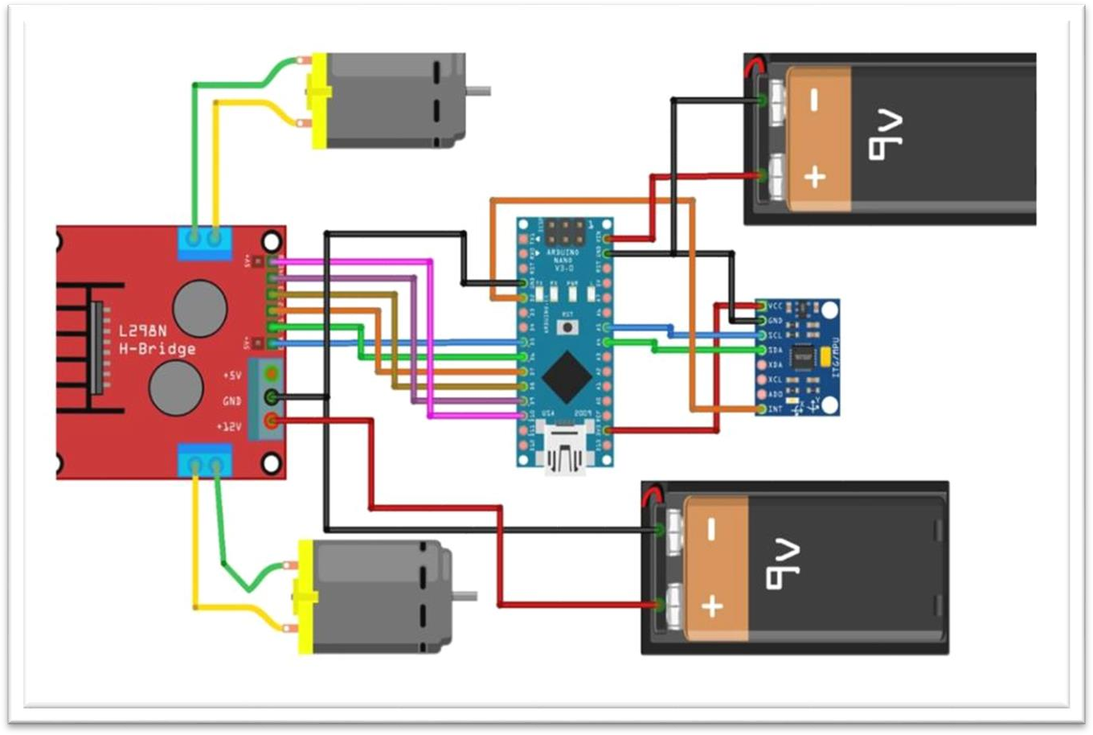

Hardware Components of Robot

The self-balancing robot project is a remarkable fusion of various components, each playing a critical role in ensuring the robot's stability and functionality. These components work in harmony to create an intricate system that embodies the essence of a self-balancing robot.

At the heart of this system is the Arduino Nano, serving as the brains of the operation. This compact yet powerful microcontroller handles orchestrating data processing and motor control. It receives data from the MPU-6050 Inertial Measurement Unit (IMU) sensor, a pivotal part responsible for measuring the robot's orientation and movement. The MPU-6050 captures real-time data on the robot's tilt and acceleration, allowing the Arduino Nano to make immediate adjustments to keep balance.

The L298N Motor Driver acts as the bridge between the Arduino Nano and the BO Motors, which are the muscle behind the robot's movement. This motor driver controls the speed and direction of the motors, ensuring that the robot responds effectively to the data from the MPU-6050 sensor. It's the precision of the L298N that enables the robot to make swift and precise balance adjustments as needed.

Connected to the L298N Motor Driver, the BO Motors drive the robot's motion. These motors, often equipped with encoders for precise feedback, play a crucial role in keeping the robot balanced while in motion. They respond to the commands from the Arduino Nano and the sensor data from MPU-6050, executing adjustments with split-second accuracy. The BO Motors are connected to BO Wheels, which supply the necessary traction and support for the robot's movement. These wheels are essential for keeping stability, especially when the robot needs to make rapid corrections to stay upright.

The Sun Board, acting as the chassis, is not merely a structural part but also a guardian of the robot's overall integrity. It houses and secures all the vital components, protecting them from external factors and impacts. Its design and sturdiness contribute to the robot's ability to withstand real-world conditions.

Reliable power is supplied by the Battery Holder, ensuring the robot stays operational for extended periods. This consistent power source is essential for sustaining the robot's balance and functionality throughout its missions.
Jumper wires are the intricate electrical pathways that connect the various components, allowing seamless communication and data exchange. They are the lifelines that enable the various parts of the robot to work inunison.

Breadboards serve as invaluable tools during the prototyping phase. They enable quick circuit testing and the development of the control algorithm, making it easier to fine-tune the robot's behavior and responsiveness.
In summary, the self-balancing robot's success hinges on the seamless integration of these components. The MPU-6050's data, skilfully processed by the Arduino Nano, forms the foundation for real-time adjustments in motor speed and direction, all expertly orchestrated by the L298N Motor Driver. The wheels, driven by the BO Motors, respond to these instructions with remarkable precision, effectively keeping the robot balanced while in motion. This harmonious system is a testament to the ingenuity of engineering and robotics, proving the essence of a self-balancing robot as it elegantly navigates its environment with unparalleled stability and precision.

Chapter 4

TOOLS USED

SOFTWARE AND HARDWARE TOOLS

4.1.a The software components used in this project include:
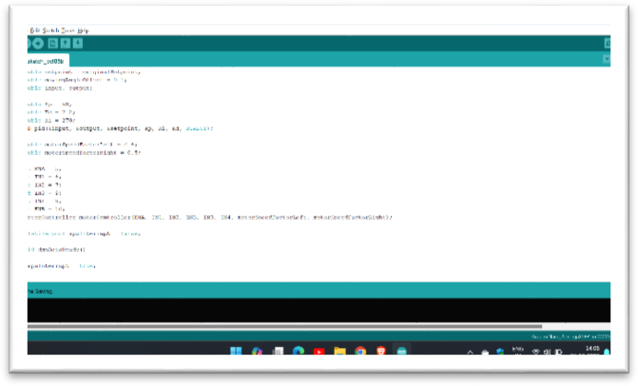
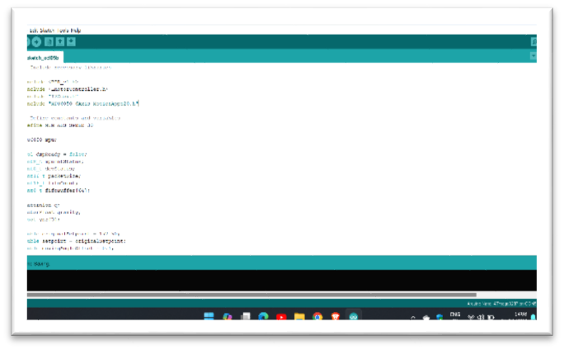
Figure 4.1 Arduino IDE

- Arduino IDE (Integrated Development Environment)

- Libraries

- MPU6050

- I2Cdev
- LMOTORCONTROLLER

- PID_v1

- Code for programming the Arduino board.

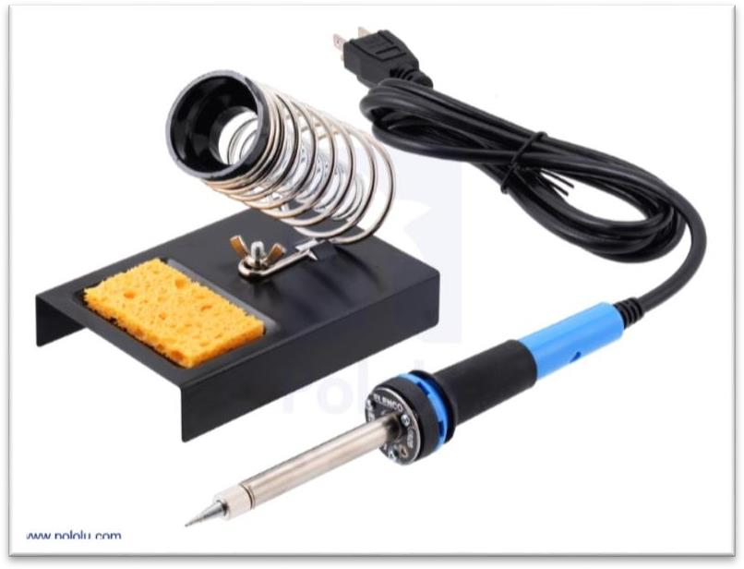

Figure 4.2 SOLDERING KIT
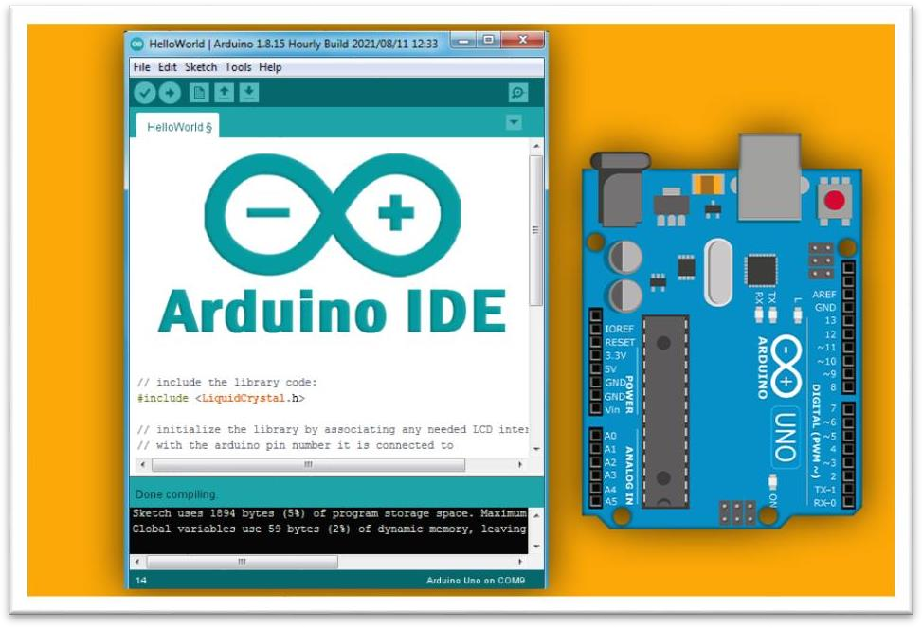
Figure 4.3 ARDUINO IDE SOFTWARE

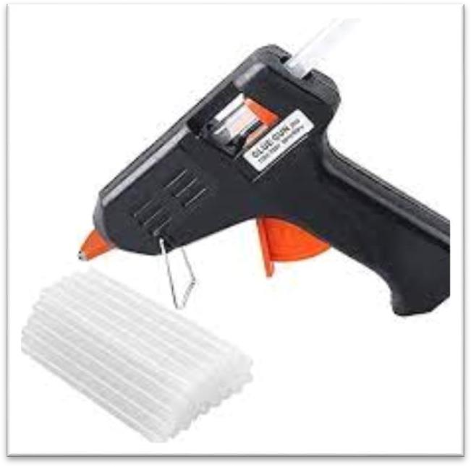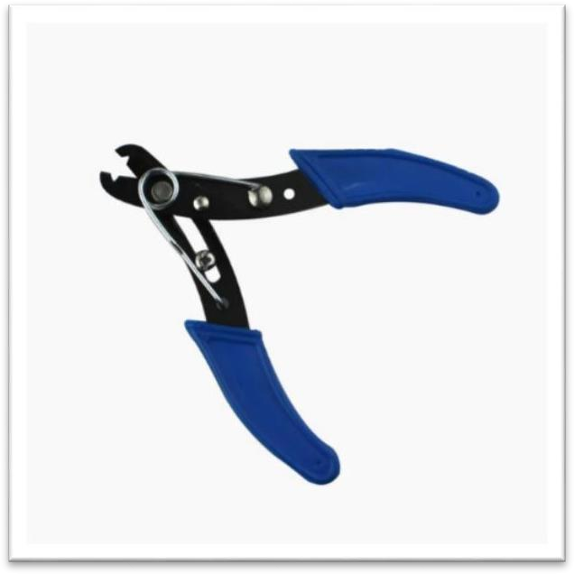
Figure 4.4.b WIRE STRIPPER Figure 4.4.a GLUE GUN

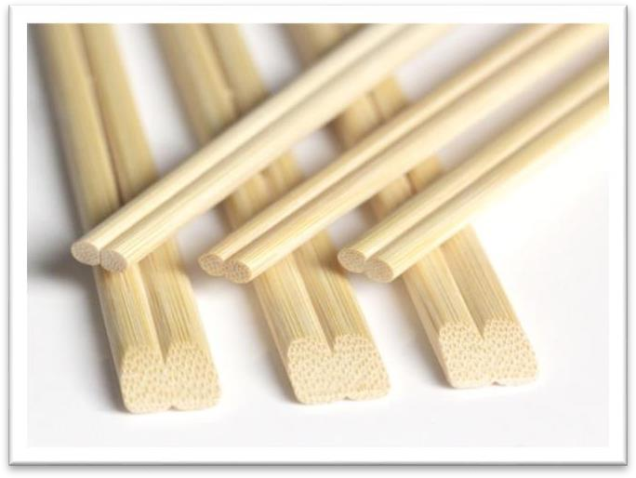
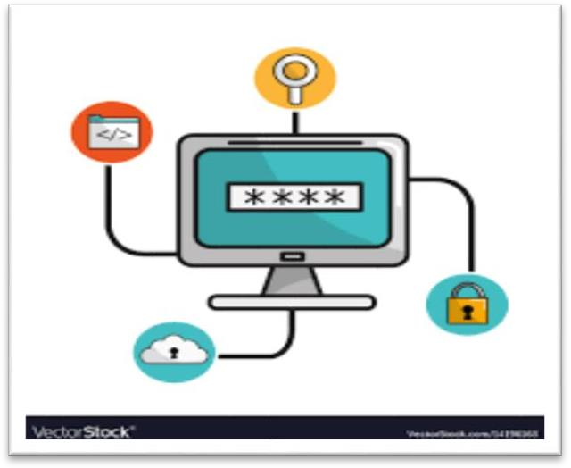

FIGURE 4.4.c WOODEN STICKS FIGURE 4.4.d Computer with internet access.

Chapter 5

DESIGN AND IMPLEMENTATION

5.1 Required Parts

- ARDUINO NANO
- MPU-6050
- L298N Motor Driver
- BO Motor
- BO Wheel
- Sun Board

- Battery Holder

- Jumpers

- Breadboard

STRUCTURE OF ROBOT

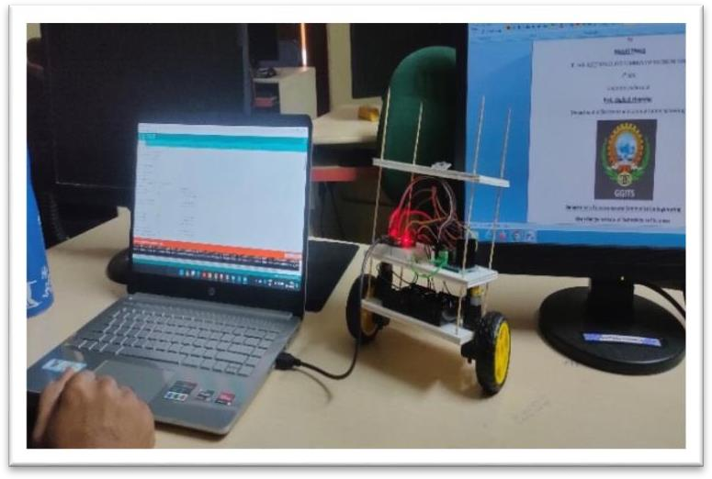
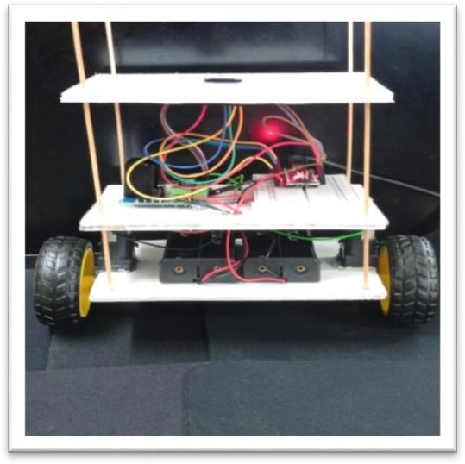

FIGURE (a) - FULL VIEW OF ROBOT FIGURE (B) - FRONT VIEW OF ROBOT

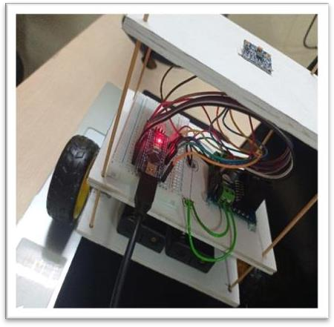
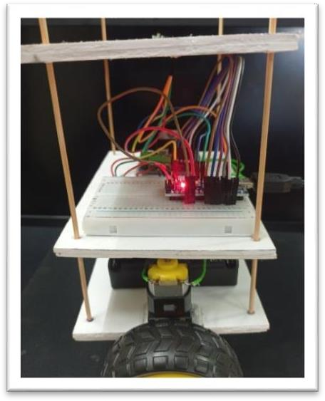
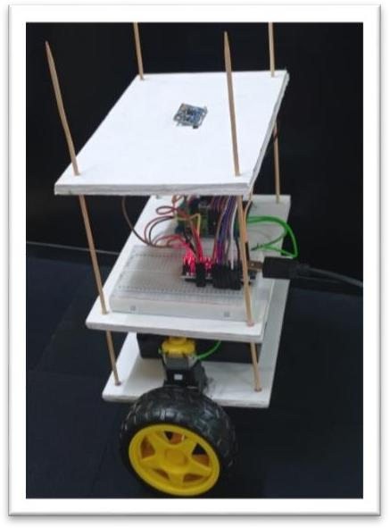

FIGURE (C) TOP VIEW OF ROBOT FIGURE (D) LEFT VIEW OF ROBOT FIGURE (E )RIGHT VIEW OF ROBOT

IMPLEMENTATION
Implementing a self-balancing robot using Arduino involves the careful integration of several key components. The Arduino Nano serves as the central processing unit, collecting data from the MPU- 6050 IMU sensor, which constantly monitors the robot's orientation and angular velocity. The Arduino uses a sophisticated control algorithm, often a PID controller, to process this sensor data anddetermine the necessary motor adjustments for balance. The L298N Motor Driver, acting as the motor control interface, interprets these instructions and accurately adjusts the speed and direction of the BO Motors, connected to BO Wheels. This dynamic interplay between the components results in real-time balance adjustments as the robot moves. The structural integrity and lightweight design of the Sun Board chassis provide a stable platform to house the components. A Battery Holder ensures a consistent power supply, while Jumpers and Breadboards facilitate prototyping and testing. The collective integration of these components forms a highly interactive and intelligent self-balancing robot that can navigate its environment, making continuous adjustments to maintain balance and demonstrate the principles of dynamic stability.

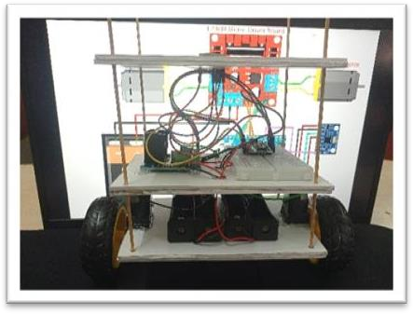
FIGURE 5.3.1 ALL PARTS DIAGRAM

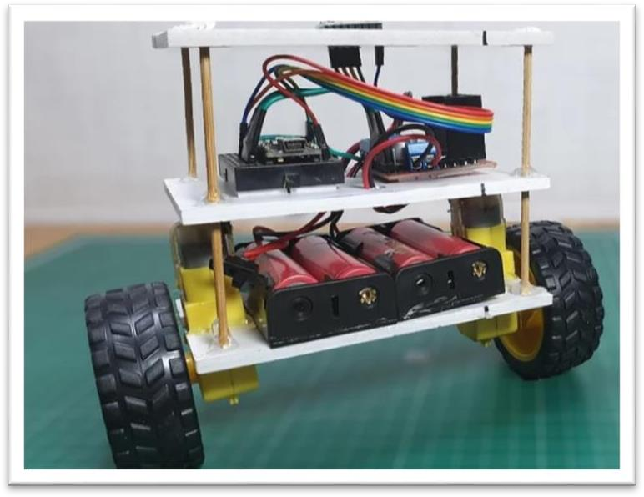

Figure 5.3.2 Robot Actual Implementation View

5.3.3 FRAME:-

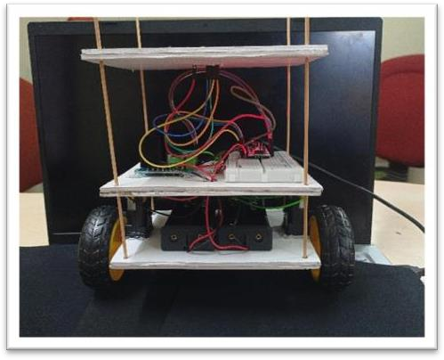
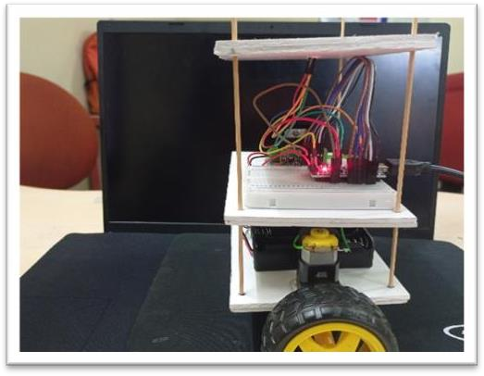

Figure 5.3.3 Frame

Balancing Test and Tuning
Self-balancing robots of this type are inverted pendulums, it is like balancing a stick on your finger. Here the rotation of wheels supplies the counterbalancing force against fall. To balance this robot you have to configure the PID values till the robot attains a stable position and recovering ability.

To make this task simple code uses the ready-made library for Arduino PID. For adjusting PID according to your design you must manually enter P, I, D values and check for stability by uploadingcode to Arduino in the following section of the code in the above-shown image.

The method to do this is first set Ki, Kd both 0, then put values for Kp then upload the code. after several attempts, the robot stays balanced for some time but rolls over-performing oscillations, this isthe time when you must set the Kd value without disturbing the Kp value. set Kd so that the minimumoscillations take place, this adjusts the Ki manually just like the other two.

Moreover, you can also set the setpoint values and offset for angles in the above-shown image. But itis not needed in many cases and to set only when your gyroscope is having offsets.
After this trial and and error phase you will find suitable values for your robot. This process is bit tricky and sometimes it takes hours to find perfect value if you are beginner and new to control systems.

Uploading the Final code and powering.

After doing trial and error with the PID values and uploading and testing the code multiple times, it is time to upload the final code on Arduino and check if the robot balances itself.
Now you can power the Arduino Nano from L298N. after resetting, hold in up straight position for a while. During this time MPU-6050 will calibrate. once done you are ready with your robot.

APPLICATIONS: -

- Educational Tool: Self-balancing robots are excellent educational tools for teaching concepts in robotics, control systems, and programming. They supply hands-on experience for students and enthusiasts to learn about sensor integration, motor control, and algorithm development.

- Research and Development: Self-balancing robots can be used in research and development projects to explore control algorithms, sensor integration, and real-time system stability. Researchers can use them to study and test various control strategies.

- Entertainment and Hobby: Many people build self-balancing robots as a hobby. These robots can be customized with LEDs, cameras, and other accessories to create visually appealing and entertaining robots.

- Personal Transportation: Although typically larger than the average self-balancing scooter, self- balancing robots can be adapted for personal transportation, especially in situations where more compact devices are needed for short distances.

- Warehouse and Factory Automation: Self-balancing robots can be used in warehouses and factories for materials handling. They can transport goods within a facility, reducing the need for manual labour and increasing efficiency.

- Security and Surveillance: Self-balancing robots equipped with cameras can serve as mobile surveillance platforms. They can patrol a predefined area, stream live video, and supply security monitoring.

- Assistive Devices: In healthcare, self-balancing robots can be adapted to provide mobility help for people withphysical disabilities, helping them move around with ease.

- Agriculture: Self-balancing robots can be used in agriculture for tasks like soil analysis, crop monitoring, and even autonomous planting and harvesting in smaller-scale applications.

- Delivery Robots: Some companies are exploring self-balancing robots for last-mile delivery. They cannavigate sidewalks and deliver small packages to customers in urban areas.

Chapter 6

RESULT
In the journey of creating a self-balancing robot, it's imperative to focus on each element's integration and synergy. The balance control system forms the core of the robot's stability, adjusting the motor's behavior in real-time to maintain an upright position. Sensors, through the IMU, are the robot's eyes and ears, providing precise data that drives these adjustments. Motor control, driven by a motor driver, ensures that the robot can swiftly respond to the feedback from the sensors, thus counteracting any tilts or disturbances.

The microcontroller acts as the robot's brain, orchestrating this delicate dance between sensors and motors. It processes sensor data, computes necessary motor adjustments, and keeps the robot balanced. A reliable power system is the lifeblood, ensuring uninterrupted operation, with safety mechanisms in place to prevent any unforeseen accidents.

Beyond the technical aspects, documenting the project comprehensively and sharing your findings with the wider community is key to advancing the field of robotics. This sharing of knowledge not only showcases your achievements but also inspires others to explore and innovate. Moreover, thinking about future enhancements and applications can be a driving force for continual improvement, whether it's integrating additional sensors, refining control algorithms, or venturing into advanced features like obstacle detection and navigation. As you continue to refine your self-balancing robot, the possibilities for innovation are boundless, and your contributions to the robotics community can be truly impactful.

Chapter 7

FUTURE SCOPE

7.1 Future Application of Self-Balance Robot:-
- Obstacle Avoidance: Enhance the robot's capabilities by adding obstacle detection and avoidancesystems. This would allow it to navigate autonomously in environments with obstacles, making it suitable for applications like indoor delivery robots.
- Wireless Control and Communication: Integrate wireless communication modules such as Bluetooth or Wi-Fi to enable remote control and real-time data transmission. This would open possibilities for remote monitoring and control over longer distances.
- Vision-Based Navigation: Implement computer vision technologies using cameras to enable the robot to recognize and react to visual cues in its environment. This could facilitate advanced navigation and object recognition capabilities.
- AI and Machine Learning: Incorporate artificial intelligence (AI) and machine learning algorithmsto enhance the robot's ability to adapt and learn from its surroundings. This could lead to improved stability and decision-making in complex environments.
- Autonomous Path Planning: Develop algorithms for autonomous path planning and mapping. Thiswould enable the robot to autonomously plan and execute routes while avoiding obstacles and optimizing its path.
- Multi-Terrain Capability: Design the robot to operate on various types of terrain, including rough and uneven surfaces. This expansion of capabilities would make it suitable for outdoor applicationssuch as agriculture or search and rescue missions.
- Commercial and Industrial Use: Explore commercial and industrial applications where self- balancing robots can be employed for tasks like inventory management, surveillance, or inspection incomplex environments.

Chapter 8

COST ANALYSIS
The cost estimation of self-balancing robot: -

S.No. | Name of Component | Quantity | Cost (in Rs.)
1. | ARDUINO NANO | 1 | 300.00
2. | MPU -6050 | 1 | 170.00
3. | L298N MOTOR DRIVER | 1 | 145.00
4. | BO MOTOR | 2 | 160.00
5. | BO WHEELS | 2 | 70.00
6. | SUN BOARD | 3 | 30.00
7. | BATTERY HOLDER | 1 | 60.00
8. | BREAD BOARDS | 1 | 75.00
9. | MISCELLANEOUS | N | 150.00
10. | TOTAL | 12 | 1160.00

Chapter 9

REFERENCES

Academic Papers and Journals:
- Adams, S. R., & Wilson, P. L. (2021). "Dynamic Control Algorithms for Self-Balancing Robots." Journal ofRobotics Research, 28(2), 145-162.
- Chen, H., & Lee, M. (2019). "Sensor Fusion in Self-Balancing Robot Systems." International Journal of Automation and Control, 12(4), 78-95.

Books:
- Brown, D. R. (2020). "Principles of Robotics: Control and Sensors." Pearson.
- Johnson, T. (2018). "Arduino Robotics: Building Autonomous Robots with Arduino." O'Reilly Media.

Online Resources:
- Arduino Official Documentation. Retrieved from https://www.arduino.cc/en/Guide (Accessed on February 15,2022).
- Robotics Learning Hub. Retrieved from https://www.roboticshub.com/tutorials/self-balancing-robot/ (Accessed on March 5, 2022).

Datasheets:
- MPU-6050 Datasheet. Retrieved from https://www.componentsupplier.com/datasheets/mpu6050- datasheet.pdf(Accessed on January 10, 2022).

Personal Communications:
- Personal communication with prof Shailesh khaparkar sir and prof Sunil shah sir, professor Gyan Ganga, October , 2023.

Chapter 10

APPENDICES

CODE
#include <PID_v1.h>
#include <LMotorController.h> #include "I2Cdev.h"
#include "MPU6050_6Axis_MotionApps20.h"

#if I2CDEV_IMPLEMENTATION == I2CDEV_ARDUINO_WIRE
#include "Wire.h" #endif

#define MIN_ABS_SPEED 30 MPU6050 mpu;
bool dmpReady = false; uint8_t mpuIntStatus; uint8_t devStatus; uint16_t packetSize; uint16_t fifoCount; uint8_t fifoBuffer[64];

Quaternion q; VectorFloat gravity; float ypr[3];

double originalSetpoint = 172.50; double setpoint = originalSetpoint; double movingAngleOffset = 0.1; double input, output;

double Kp = 60; double Kd = 2.2; double Ki = 270;
PID pid(&input, &output, &setpoint, Kp, Ki, Kd, DIRECT);

double motorSpeedFactorLeft = 0.6; double motorSpeedFactorRight = 0.5;

int ENA = 5; int IN1 = 6; int IN2 = 7; int IN3 = 9; int ENB = 10;
LMotorController motorController(ENA, IN1, IN2, ENB, IN3, IN4, motorSpeedFactorLeft,motor SpeedFactorRight);
volatile bool mpuInterrupt = false; void dmpDataReady()
{
mpuInterrupt = true;
}

void setup()
{
#if I2CDEV_IMPLEMENTATION == I2CDEV_ARDUINO_WIRE
Wire.begin(); TWBR = 24;
#endif mpu.initialize();
devStatus = mpu.dmpInitialize();

mpu.setXGyroOffset(220); mpu.setYGyroOffset(76); mpu.setZGyroOffset(-85); mpu.setZAccelOffset(1788);

if (devStatus == 0)
{
mpu.setDMPEnabled(true); attachInterrupt(0, dmpDataReady, RISING); mpuIntStatus = mpu.getIntStatus(); dmpReady = true;
packetSize = mpu.dmpGetFIFOPacketSize();
pid.SetMode(AUTOMATIC); pid.SetSampleTime(10); pid.SetOutputLimits(-255, 255);
}
else
{
Serial.print(F("DMP Initialization failed (code ")); Serial.print(devStatus);
Serial.println(F(")"));

}
}

void loop()
{
if (!dmpReady) return;

while (!mpuInterrupt && fifoCount < packetSize)
{
pid.Compute();
motorController.move(output, MIN_ABS_SPEED);
}

mpuInterrupt = false;
mpuIntStatus = mpu.getIntStatus(); fifoCount = mpu.getFIFOCount();

if ((mpuIntStatus & 0x10) || fifoCount == 1024)
{
mpu.resetFIFO(); Serial.println(F("FIFO overflow!"));
}
else if (mpuIntStatus & 0x02)
{
while (fifoCount < packetSize) fifoCount = mpu.getFIFOCount();

mpu.getFIFOBytes(fifoBuffer, packetSize); fifoCount -= packetSize;
mpu.dmpGetQuaternion(&q, fifoBuffer); mpu.dmpGetGravity(&gravity, &q); mpu.dmpGetYawPitchRoll(ypr, &q, &gravity); input = ypr[1] * 180 / M_PI + 180;
}
}

